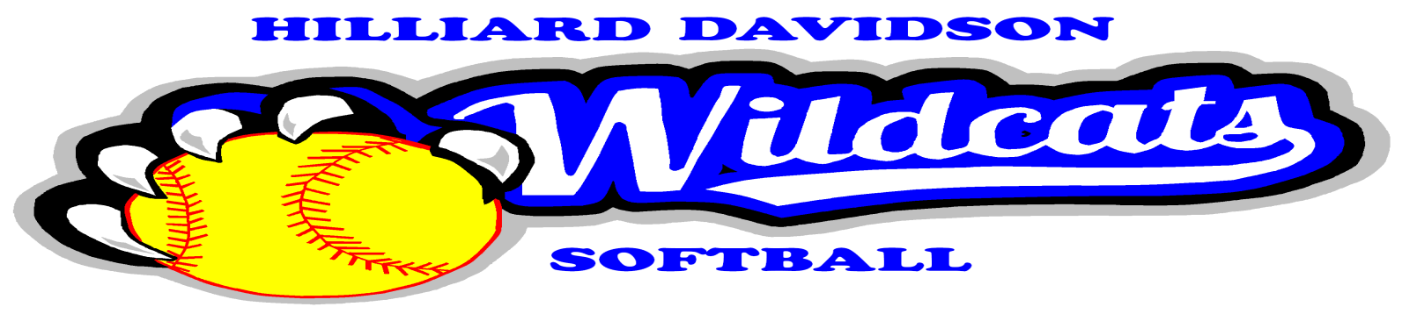
Hilliard Davidson High School Home Run Club
Banner Advertising Sales Contract
We agree to a one, two or three year contract as indicated below for the HDHS Home Run Club banner advertising program beginning in the Spring 2016 season. Attached is our logo artwork. We agree to pay the following.
____________ $350 three year commitment, check payable to HDHS Home Run Club.
____________ $300 two year commitment, check payable to HDHS Home Run Club.
____________ $250 one year commitment, check payable to HDHS Home Run Club.
In return, my business will receive a 4’ x 4’ all weather banner (Dark Blue Background with White Lettering) to be displayed at the Hilliard Davidson High School varsity softball field.
Name of Business Contact

Business Address

Business Phone Contract Start Date

e-mail Address Contract End Date

Signature of Business Contact Date
___________________________________________________________________________________________________________
For Home Run Club Use Only:
Check No.
Date Received
Artwork Enclosed

